**Front End Engineering-II**

Project Report

Semester-IV (Batch-2022)

**Palindrome Checker**



**Supervised By: Submitted By:**

**Raveesh Samkaria Name:- Vaani**

**Roll No:- 2210990930**

**Department of Computer Science and Engineering**

**Chitkara University Institute of Engineering & Technology, Chitkara University, Punjab**

**Abstract:**

The "Palindrome Checker" website offers a simple yet powerful tool for verifying whether a given sequence of characters forms a palindrome. Palindromes, sequences that read the same forwards and backwards, hold a fascinating allure in various linguistic, mathematical, and cultural contexts. From words and phrases to numbers and entire sentences, palindromes inspire curiosity and delight in enthusiasts of all ages.

Our website provides users with an intuitive interface where they can input their desired sequence, whether it be a word, phrase, number, or any combination thereof. The underlying algorithm swiftly processes the input and determines whether it exhibits palindromic properties. Users receive instant feedback, indicating whether the sequence is indeed a palindrome or not.

Beyond its utility as a tool for amusement and exploration, the Palindrome Checker serves practical purposes across diverse fields. In linguistics, it aids in analyzing linguistic structures and patterns. In computer science, it offers insights into algorithmic efficiency and string manipulation. Moreover, it fosters educational opportunities, engaging users in interactive exercises to enhance their understanding of symmetry and sequence manipulation.

The website's accessibility and user-friendly design cater to a broad audience, from students and educators to puzzle enthusiasts and professionals. Whether you're exploring the intricacies of language, testing your coding skills, or simply marveling at the wonders of symmetry, the Palindrome Checker website invites you to delve into the captivating world of palindromes.

**Index**

|  |  |  |
| --- | --- | --- |
| Sr.no. | Topics | Page no. |
| 1. | INTRODUCTION | 4-6 |
| 2. | SCOPE | 7 |
| 3. | PROBLEM DEFINITION AND REQUIREMENTS | 8 |
| 4. | CODE | 9 |
| 5. | SNAPSHOT | 10-12 |
| 6. | Folder Structure | 13 |
| 7. | References | 14 |

**1.** **Introduction**

Welcome to the Palindrome Checker website, where the fascination with symmetry meets the power of technology. Palindromes, those intriguing sequences that read the same forwards and backwards, have captivated minds for centuries. From ancient civilizations to modern-day enthusiasts, the allure of palindromes transcends cultural and linguistic boundaries.

Our website is dedicated to exploring and celebrating the beauty of palindromes through a convenient and user-friendly platform. Whether you're a seasoned linguist, a curious student, or someone simply intrigued by the wonders of language and mathematics, our Palindrome Checker offers a valuable resource for exploration and discovery.

With just a few clicks, users can input their desired sequence, whether it's a word, phrase, number, or even a combination thereof. Our robust algorithm swiftly processes the input and provides instant feedback, indicating whether the sequence exhibits palindromic properties.

But our website is more than just a tool for verifying palindromes; it's a gateway to understanding the underlying principles of symmetry and sequence manipulation. Through interactive exercises and educational content, users can deepen their appreciation for the intricate patterns found within language and mathematics.

Whether you're here to test your skills, unravel linguistic mysteries, or simply marvel at the elegance of symmetry, we invite you to embark on a journey of exploration with the Palindrome Checker website. Join us as we delve into the fascinating world of palindromes and unlock the secrets hidden within these mesmerizing sequences.

**1.1 Background:**

**1. Inspiration from linguistic curiosity:** The idea for the Palindrome Checker website originated from a shared fascination with linguistic phenomena, particularly the timeless appeal of palindromes.

**2.** **Recognizing the universal intrigue:** Palindromes, with their symmetrical allure, have intrigued people across cultures and generations, sparking curiosity in fields ranging from literature to mathematics.

**3. Identifying a need for accessibility:** Despite the widespread interest in palindromes, there was a lack of a centralized, accessible platform for efficiently verifying palindromic sequences.

**4. Mission to fill a gap:** Motivated by this observation, our team embarked on a mission to create a user-friendly website that not only serves as a practical tool for verifying palindromes but also cultivates a community of palindrome enthusiasts.

**5. Empowering Users Through Technology:** Leveraging the power of technology, we aimed to empower individuals of all backgrounds to effortlessly explore and appreciate the beauty of palindromes.

**1.2 Objectives:**

**1. Verification:** Provide a reliable tool for users to verify whether a given sequence of characters forms a palindrome.

**2. Accessibility:** Ensure accessibility to individuals of all backgrounds and ages, fostering inclusivity and participation in the exploration of palindromes.

**3. User-Friendly Interface:** Design an intuitive and easy-to-use interface that allows users to input sequences and receive instant feedback on their palindromic properties.

**4. Education:** Serve as an educational resource by offering explanations and examples of palindromes, helping users deepen their understanding of linguistic symmetry.

**5. Community Building:** Foster a community of palindrome enthusiasts by providing forums, discussions, and sharing opportunities for users to connect and exchange ideas.

**1.3 Significance:**

**1. Educational Tool:** Palindrome Checkers provide an interactive platform for individuals to learn about symmetry, linguistic structures, and pattern recognition. They offer an opportunity for students to engage with concepts in language and mathematics in a practical and hands-on manner.

**2. Language Exploration:** Palindromes are intriguing linguistic phenomena that transcend cultural and linguistic boundaries. By verifying palindromes, users can explore the symmetry and patterns within words, phrases, and sentences, fostering a deeper appreciation for language.

**3. Cognitive Development:** Using a Palindrome Checker stimulates cognitive processes such as critical thinking, problem-solving, and pattern recognition. It encourages users to analyze sequences of characters and understand their symmetrical properties.

**4. Entertainment and recreation:** Palindromes often evoke a sense of playfulness and amusement. Palindrome Checkers provide a source of entertainment for users who enjoy exploring linguistic puzzles and challenges.

**5. Algorithm Understanding:** Behind the functionality of a Palindrome Checker lies an algorithm designed to efficiently verify palindromic sequences. Users can gain insights into algorithmic principles such as string manipulation and algorithm efficiency.

**2. Scope:**

**1. Functionality:**

* **Input Processing:** Accepting various types of input, including words, phrases, numbers, and alphanumeric combinations.
* **Palindrome Verification:** Efficiently determining whether the input sequence exhibits palindromic properties.
* **Instant Feedback**: Providing immediate feedback to users regarding the palindromic nature of the input sequence.
* **User Interface:** Designing an intuitive and user-friendly interface for seamless interaction.

**2. Target Audience:**

* **Students:** Providing educational resources and interactive exercises to enhance understanding of symmetry and linguistic patterns.
* **Linguists:** Offering tools for linguistic analysis and exploration of palindromes in different languages and contexts.
* **Puzzle Enthusiasts:** Creating challenges, quizzes, and interactive content to engage users in palindromic puzzles and games.
* **Professionals:** Supporting practical applications of palindromes in fields such as computer science, cryptography, and data validation.

**3. Educational Value:**

* **Explanation of Concepts**: Offering explanations and examples of palindromes to aid in understanding their significance and properties.
* **Learning Resources:** Providing educational materials, articles, and tutorials on topics related to palindromes, symmetry, and linguistics.
* **Interactive Learning:** Engaging users through interactive exercises, quizzes, and activities to reinforce learning and retention.

**4. Applications:**

* **Linguistic Analysis:** Supporting linguistic research and analysis by providing tools for examining palindromes and linguistic structures.
* **Algorithm Development:** Serving as a platform for testing and developing algorithms for palindrome verification and string manipulation.

**3.Problem statement and Requirements :-**

**3.1 Problem Statement:**

The problem statement of a palindrome checker typically involves designing a program or function that determines whether a given input string is a palindrome or not. A palindrome is a word, phrase, number, or other sequence of characters that reads the same forward and backward (ignoring spaces, punctuation, and capitalization).

So, the task for a palindrome checker is to take a string as input and return a boolean value indicating whether the input string is a palindrome or not. The checker should consider the string's characters in a case-insensitive manner and should ignore any non-alphanumeric characters (such as spaces or punctuation) when determining palindromic properties.

**3.2 Requirements:**

**1. Input Interface:** Users should be able to input a string (or a sequence of characters) to check if it's a palindrome

**2. Processing Logic:** The program should handle both strings and phrases, considering case sensitivity (or optionally ignore it, depending on requirements). It should ignore spaces, punctuation, and any other non-alphanumeric characters while checking for palindrome properties.

**3. Palindrome Detection:** Implement the logic to determine whether the given input is a palindrome or not.

**4. Output Interface:**  Provide a clear output message indicating whether the input is a palindrome or not.

**4. Code:**

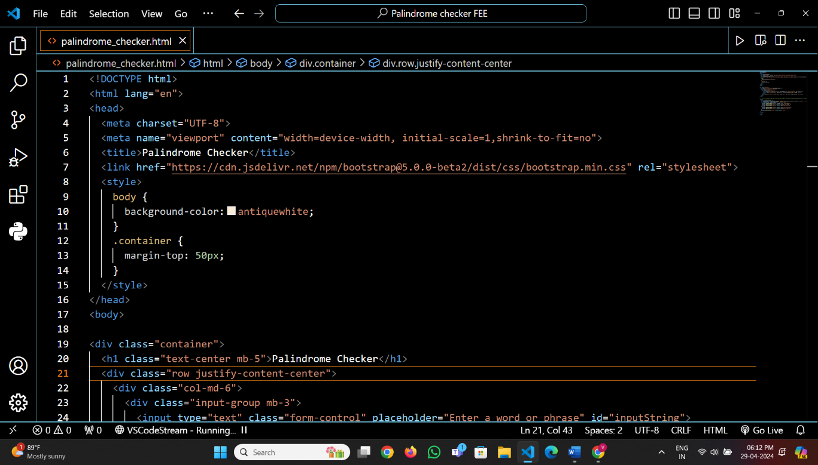

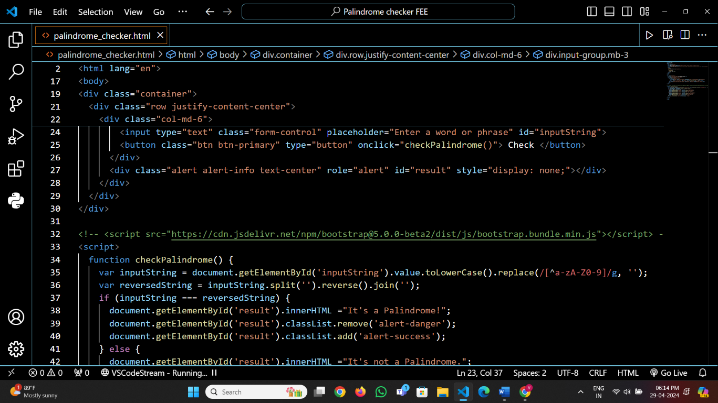

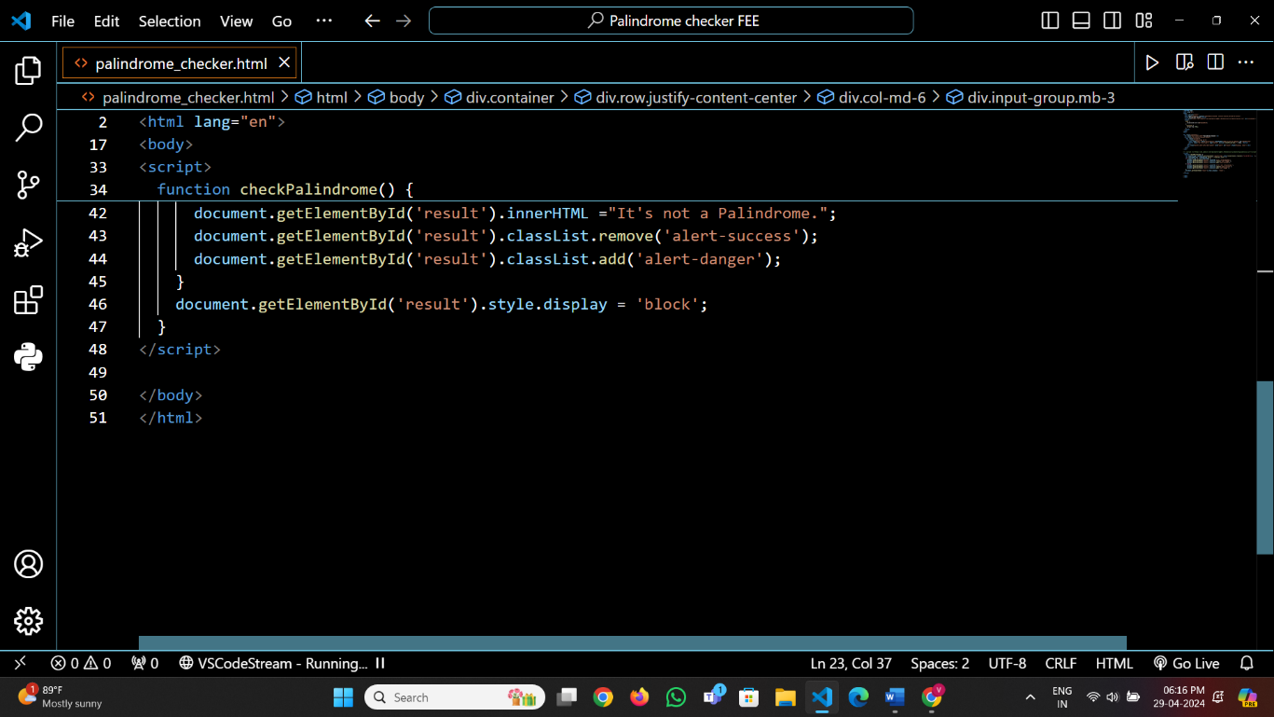

**5. Snapshot of result:**

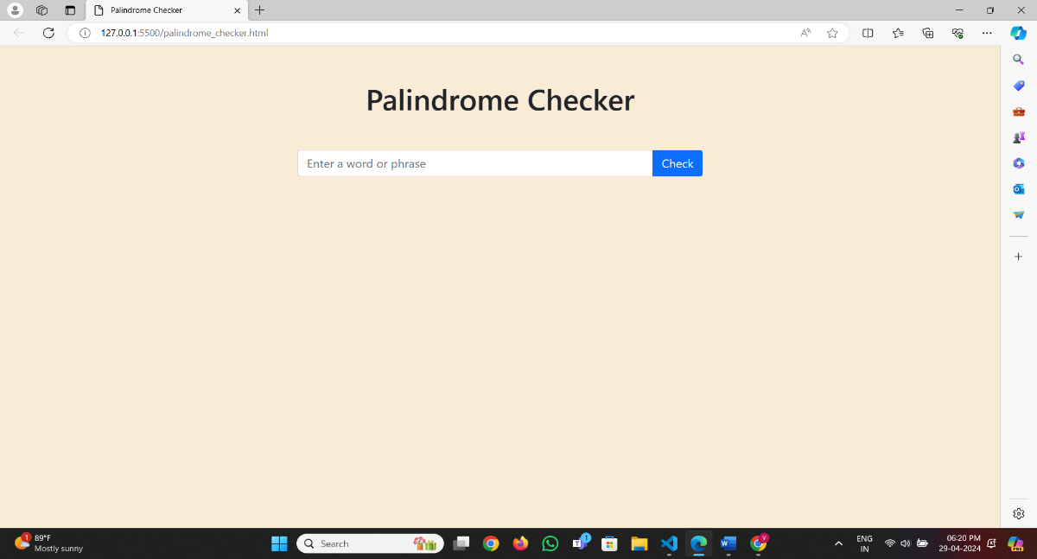

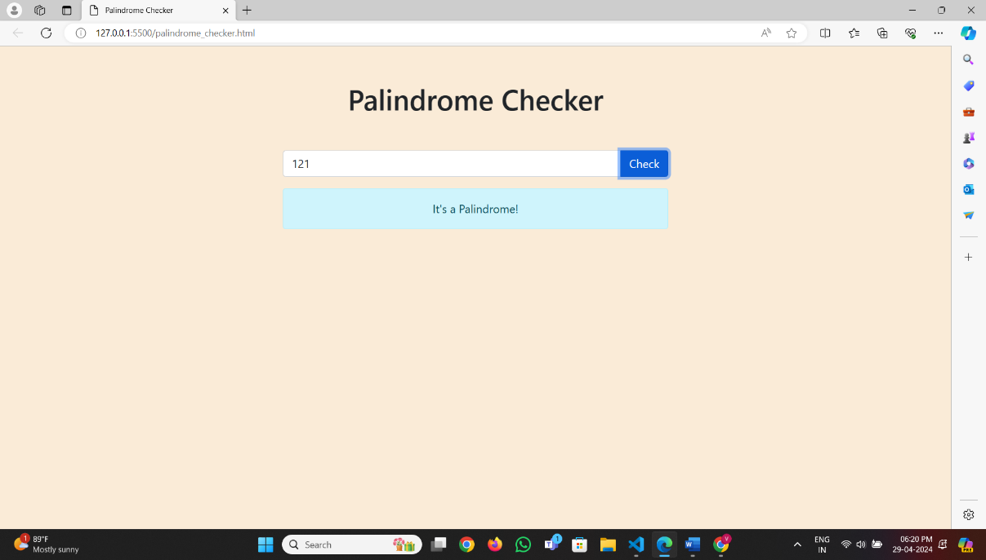

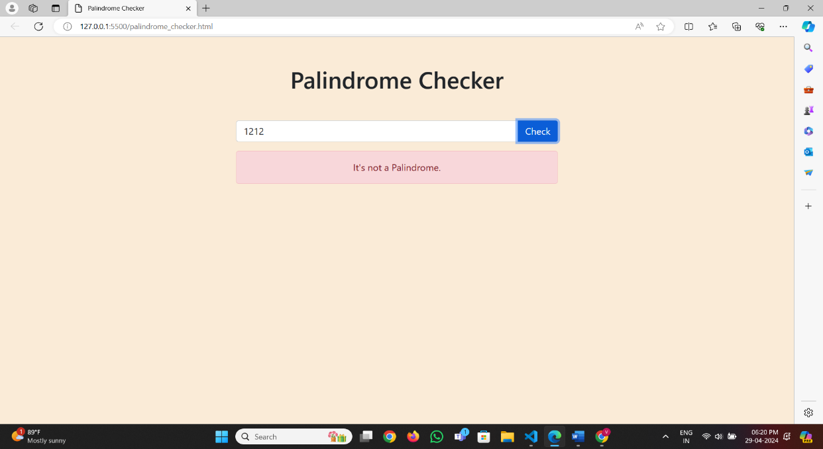

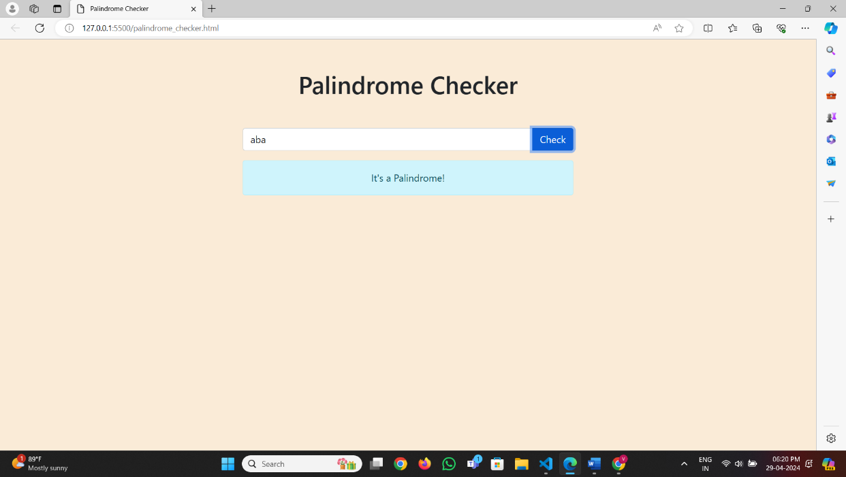

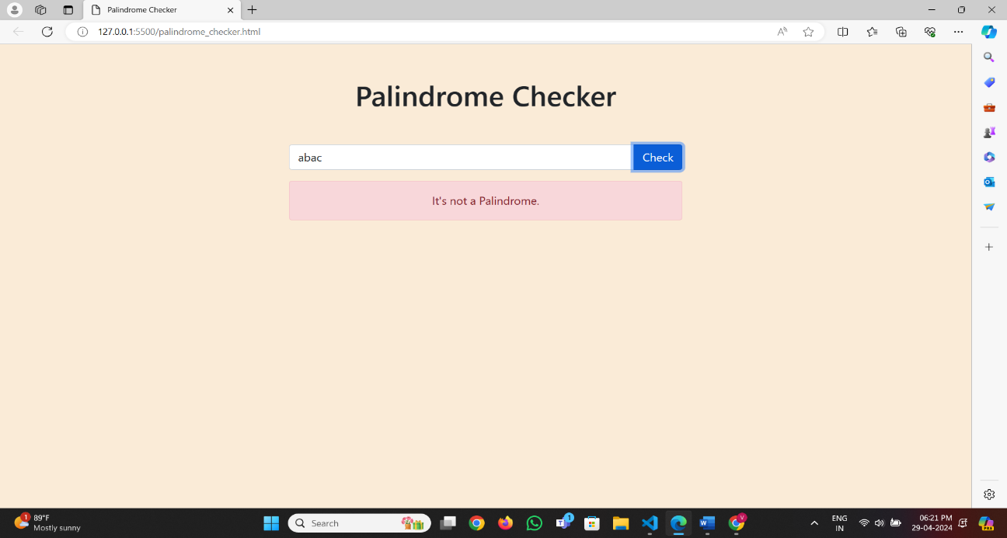

**6. Folder Structure:**

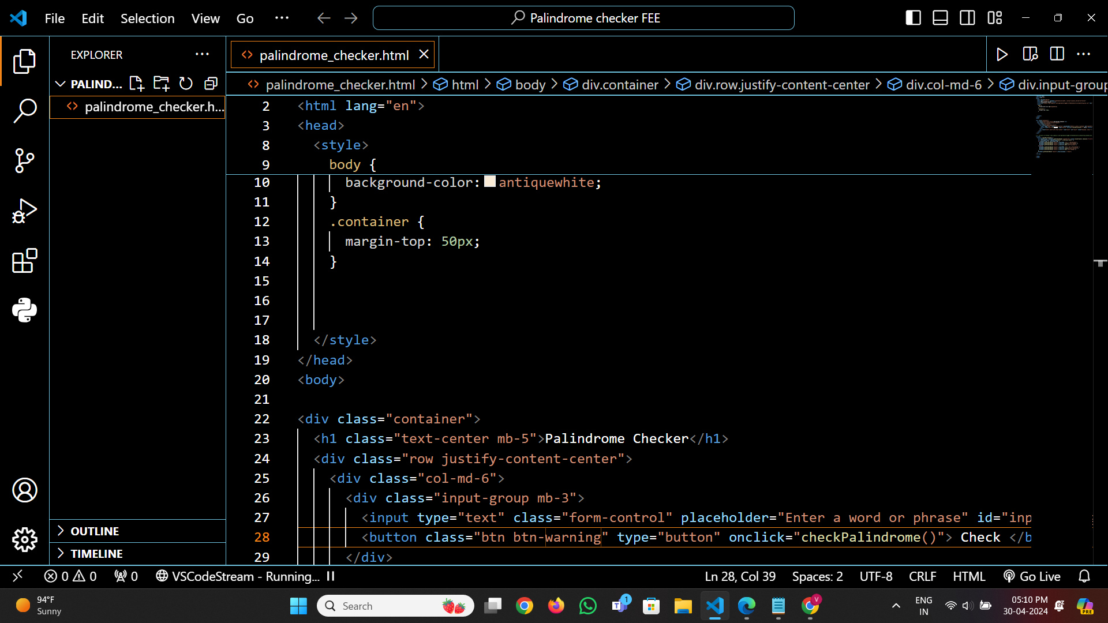

**7. References:**

**1. *Bootstrap link:***  <https://getbootstrap.com/>

**2. *Fonts:***  <https://fonts.google.com/>